How do you make Plarn step by step?
How to Make Plarn
- Step 1: Flatten Out Bag. collect lots of plastic shopping bags. ...
- Step 2: Cut Top and Bottom Off of Bag. ...
- Step 3: Fold the Bag Lengthwise. ...
- Step 4: Fold the Strip. ...
- Step 5: Cut in Half. ...
- Step 6: Cut Strips in Thirds. ...
- Step 7: Open Strips and Attach Together. ...
- Step 8: Roll Your Plarn Into a Ball and Create Something.

Step 1: Flatten Out Bag
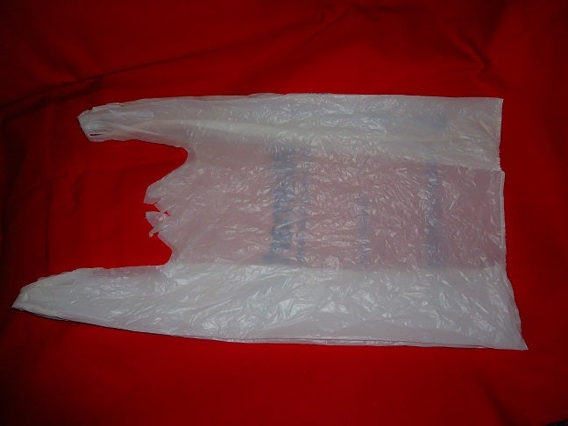
collect lots of plastic shopping bags.
flatten out the bag by pulling at both ends.

Step 2: Cut Top and Bottom Off of Bag
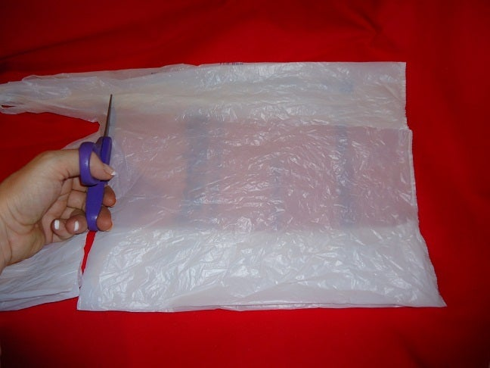
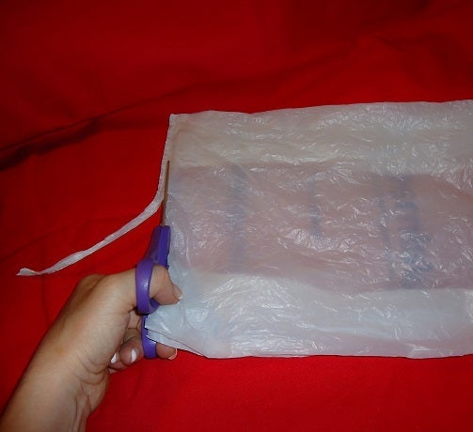
Cut the handles off of the top of the bag in a straight line.
Then cut the bottom seam off of the bag in a straight line.

Step 3: Fold the Bag Lengthwise
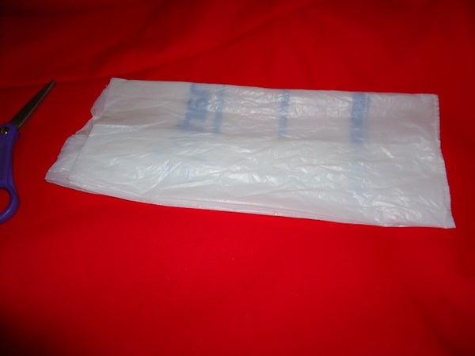

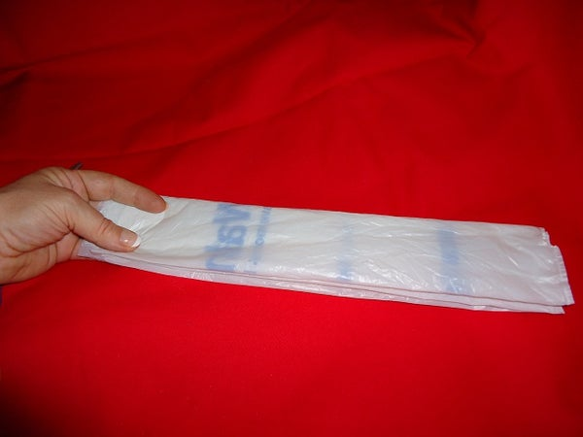
Fold the bag lengthwise in half, then in half again.

Step 4: Fold the Strip
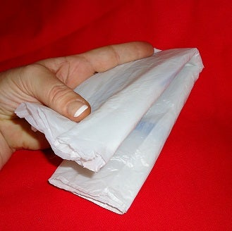
Fold the strip in half lengthwise.

Step 5: Cut in Half
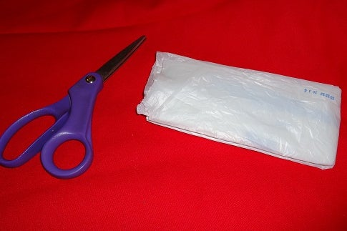

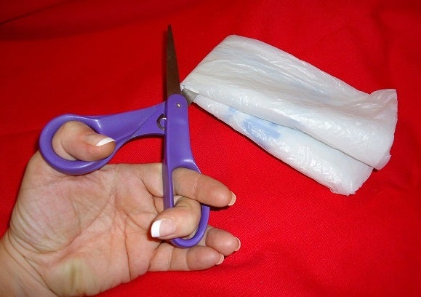
cut the strip in half at fold.

Step 6: Cut Strips in Thirds
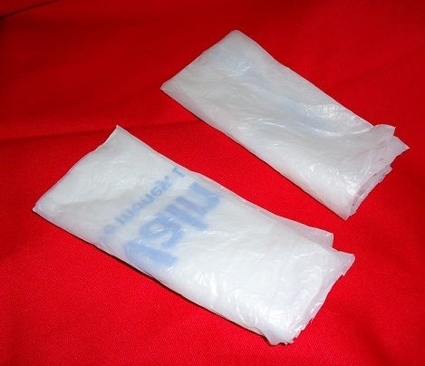

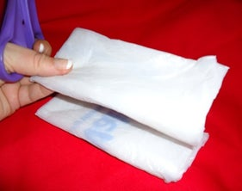
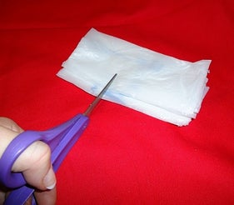
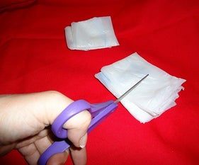
cut strips into three pieces.
Step 7: Open Strips and Attach Together
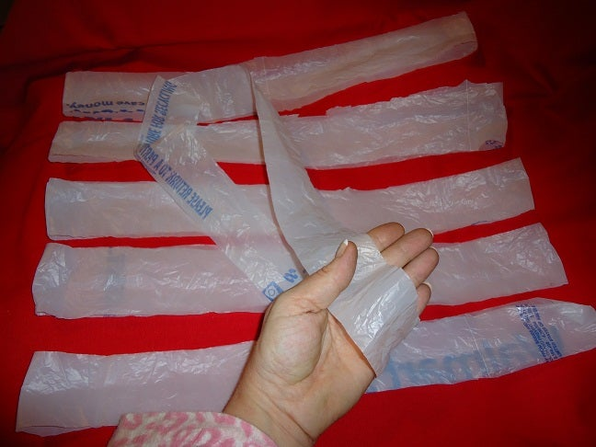
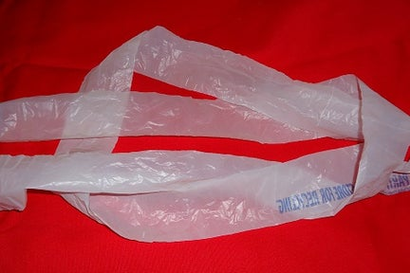
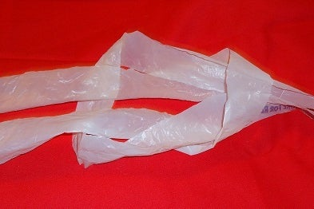
2 More Images
Open each of the six strips.
Take two strips and loop them inside each other.
Pull each end until there is only a small knot.
Then keep attaching one loop at a time to the end
until you have a ball of yarn.
If the bag has a hole, that’s okay. Or if the loop is not closed.
Just tie a knot so your plarn doesn’t come apart.
Roll into a yearn ball

Then braid or crochet with a large needle to make a blanket roll, make ties or carry handle to keep
STEP 2: Crocheting the Mat 1. You’ll need a crochet hook size 10 or above. If you get a really large crochet hook, you will find that it’s easier to crochet looser, making the mat more cushiony, and making it more comfortable to crochet with the plastic. 2. MAT CROCHET PATTERN: Set-up: ch 42. This is the width of your mat (minus 2 st), and should be approximately 2 1/2 feet-wide. 3. Row 1: sc into the 40th st, and sc all the way across. ch 2. Turn over work. Now, check that your mat is indeed about 2.5 feet wide. 4. Row 2 – 6ft worth of rows: repeat row 1 until your mat is approximately 6 feetlong mat. inches in length. 5. Cast off.

Braiding the Plarn
- Tie the ends of the three 8-foot balls of plarn to the bottom of a clotheshanger, leaving a 5-inch piece of plarn beyond the knots. In other words, the tied-to-the-coat-hanger plarn should have a fringe.
- Separate the three pieces of tied-to-the-coat-hanger plarn and begin to braid them, crossing the left strip over the middle, then the right strip over the middle into a basic flat braid. Continue until you're 5 inches from the end, then tie the ends together.
- Untie the braids from the coat hanger. Tie the three ends you just untied together again in an overhand knot.
- Make at least five more plarn braids. Each braid will take three of the balls of plarn you made in Section 1.

Attaching the braids
- Use a large crochet hook to weave the fringe down each braid, hiding it. Weave the yarn under each V in the braid by pulling it through with the hook. Work from left to right and right to left down both sides of the braid until you've woven in all the fringe at both ends of each strand. The fringe is the section of three ends left at each end of the knot. The number of braids required for the project depends on the size of rug you want to make.
- Thread a large darning needle with thin, clear fishing line. Tie the line together at the ends after threading it through the needle or tape it with a piece of clear tape.
- Sew the ends of each braid together edge-to-edge to make one very long braid. Tie and cut the fishing line on each end of the sewn sections just as you would with regular hand-sewing.
- Thread another long piece of fishing line. Curl one end of the yarn in on itself, then continue curling the yarn in a spiral, sewing the inner edge of the braid with a whip stitch as you go to hold the braids together.
- Tie off the fishing line at the end, leave a long tail, and weave the tail into the rug, toward the middle, until all the line is hidden.

